# **Short project plan**

## **Title:**

Store Project

## **Team members:**

Member 1

Member 2

Member 3

## **Results:**

Admin can Make CRUD operation (Create, Read, Update, Delete) on Products on store and customers and manage Store.

Customer can show Products and make order, and system show total price for orders.

### **Project in MVC(Model, View, Controller) Design pattern**

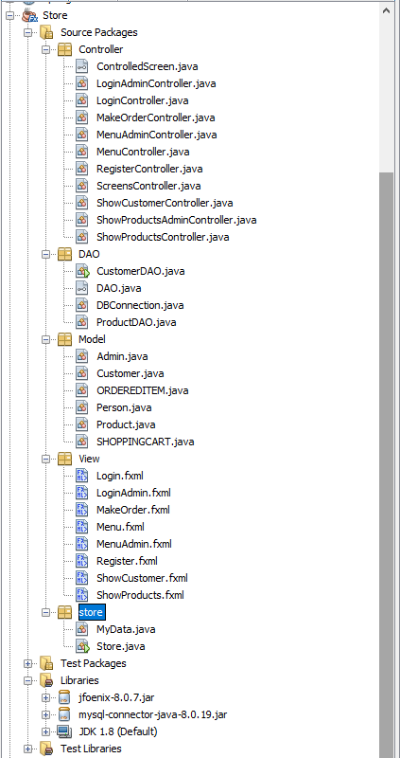

### Package store

Have Driven class (Store.java) and

data class that store admin, customer and shopping cart information (MyData.java).

### Package View :

have fxmls files that have program design layout

### Package Controller

having controller classes that control between views,

models and Database.

### Package Model:

have Entities in my project like:

* Admin
* Customer
* OrderedItm:
* Person
* Product
* ShoppingCard

### Package DAO (Data Access Object)

Have classes that deal with Database and put into  
 models, make CRUD operation on it.

